---------------------------------------------------------
Linner Hall
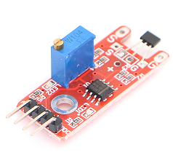
Linner Hall module can connect UNO R3 PIN13, make magnetic test.
Pin 13’s LED，use magnetic module connect Pin 3. When hall module test there is magnetic, led can be bright.

Code:
int Led=13;//定义LED 接口
int buttonpin=3; //定义线性霍尔磁力传感器接口
int val;//定义数字变量val
void setup()
{
pinMode(Led,OUTPUT);//定义LED 为输出接口
pinMode(buttonpin,INPUT);//定义线性霍尔磁力传感器为输出接口
}
void loop()
{
val=digitalRead(buttonpin);//将数字接口3的值读取赋给val
if(val==HIGH)//当线性霍尔磁力传感器检测有信号时，LED 闪烁
{
digitalWrite(Led,HIGH);
}
else
{
digitalWrite(Led,LOW);
}
}

